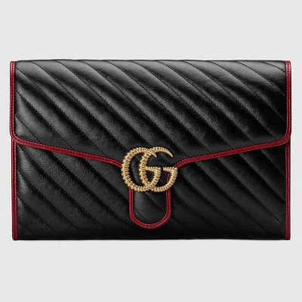

GG Marmont clutch

PRODUCT DETAILS

**The GG Marmont bag is reimagined for Pre-Fall 2019 in black diagonal matelassé**

**quilted leather, trimmed with contrast cerise piping. The clutch's softly structured shape is**

**completed with a back open pocket and oversize flap closure embellished with the**

**collection's distinct Double G in a twisted torchon design.**